AI Assisted Problem Solving Using Python

Name: Mettu Nandini
MTech – 1st Year
HTNO: 2505B04208

Lab 16 – Database Design and Queries: Schema Design and SQL Generation

Task Description -1 –Schema Generation
Task: Ask AI to design a schema for a Library Management System (Tables: Books, Members, Loans).

SQL Code
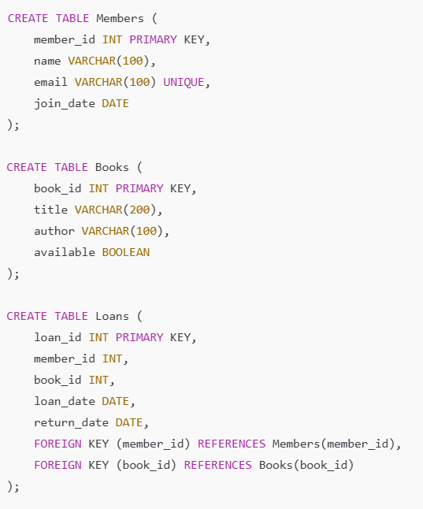

Code:
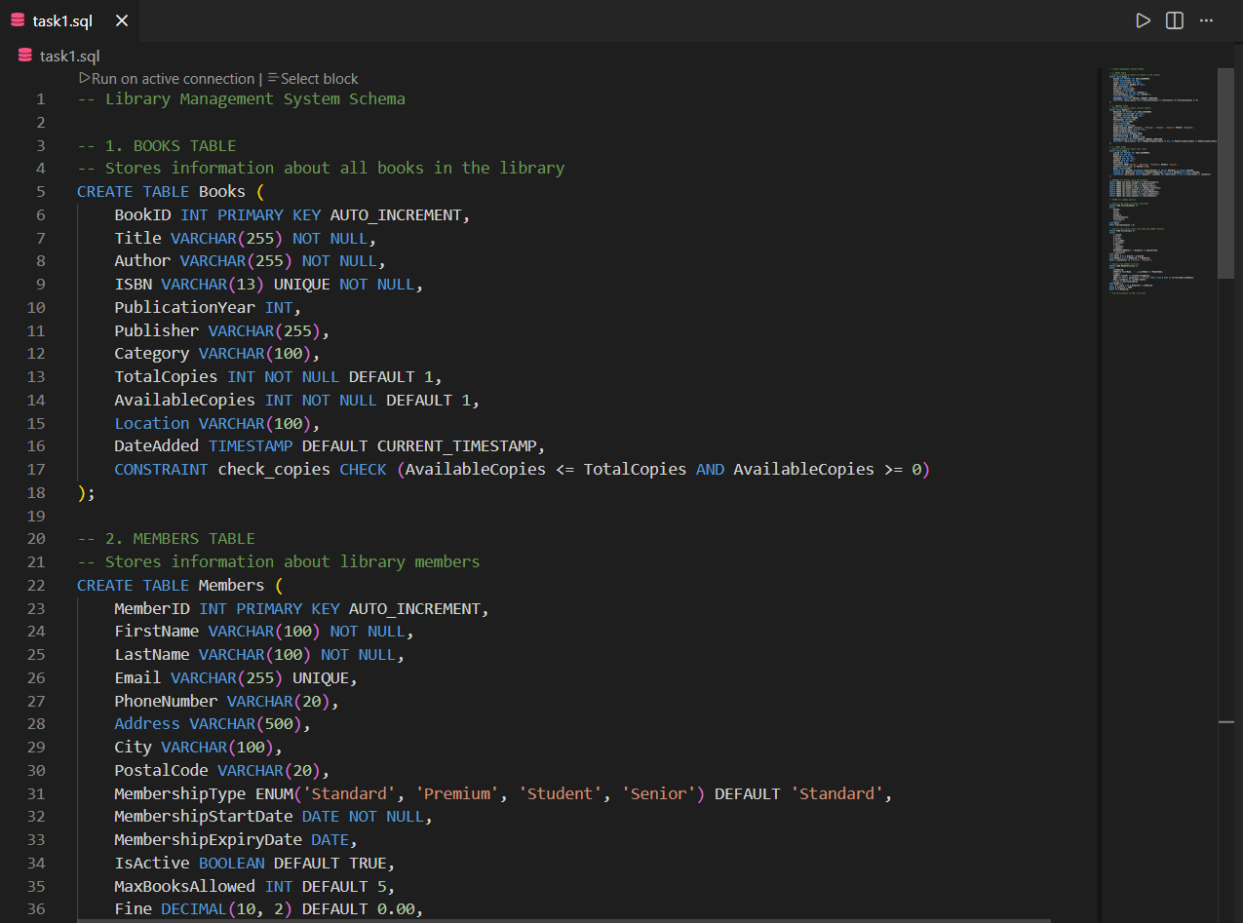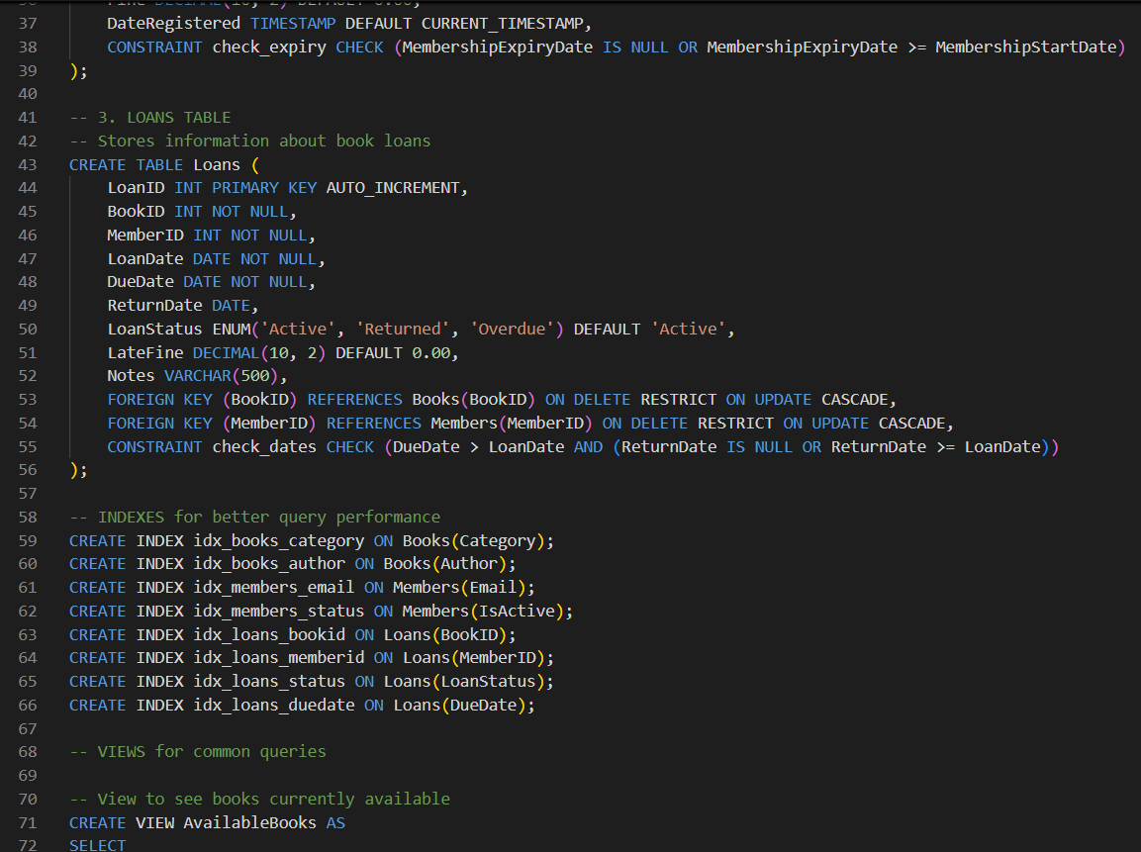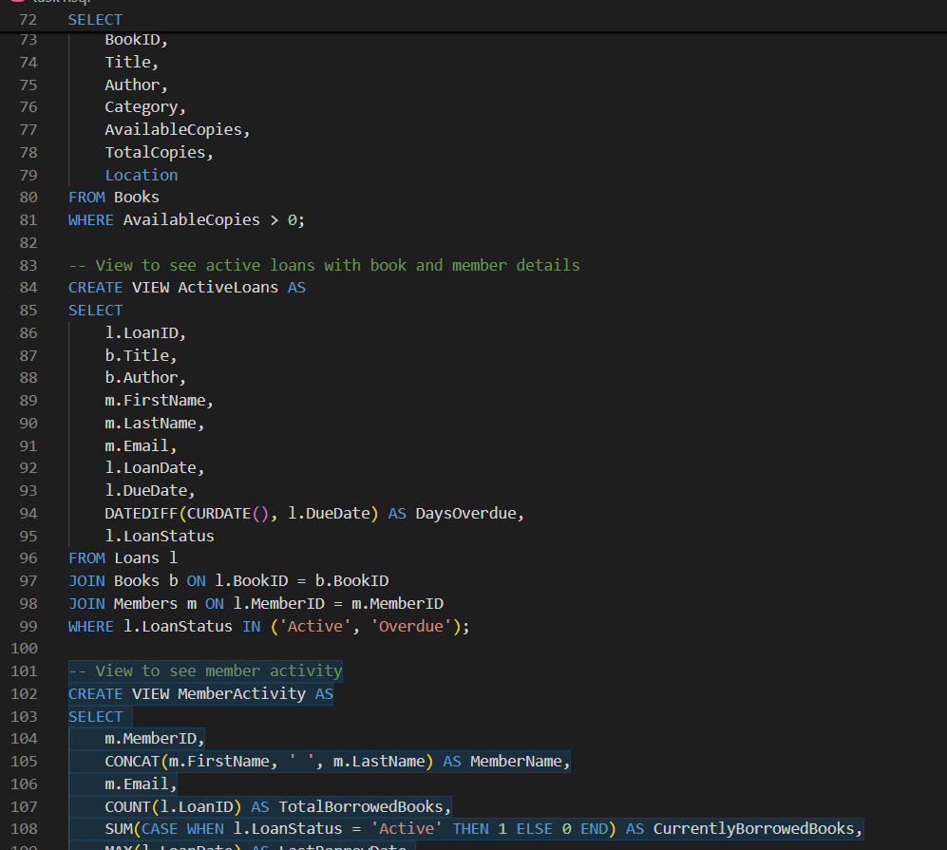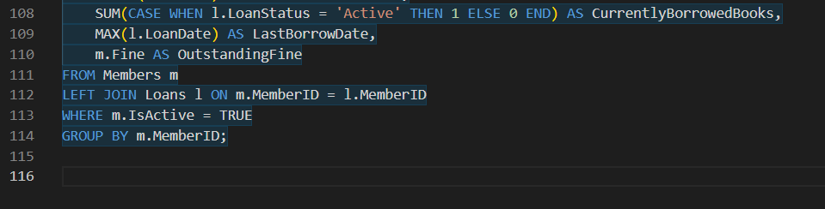
Task Description - 2 –Error Insert Data
Task: Ask AI to generate INSERT INTO queries for the schema above (3 sample records per table).
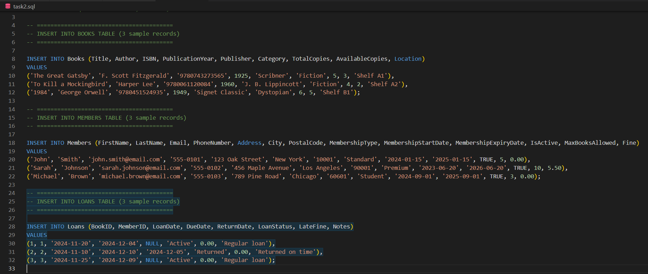
Output:
Books Table
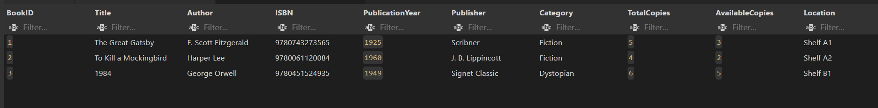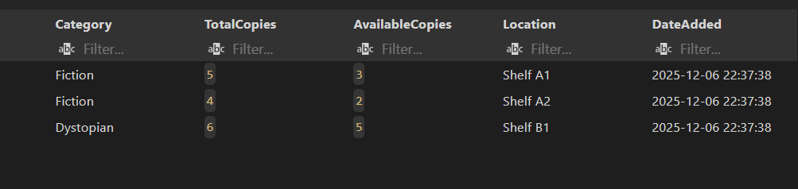
Loans Table
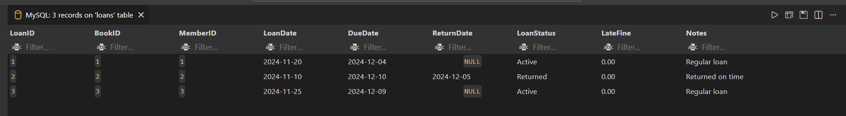
Members Table
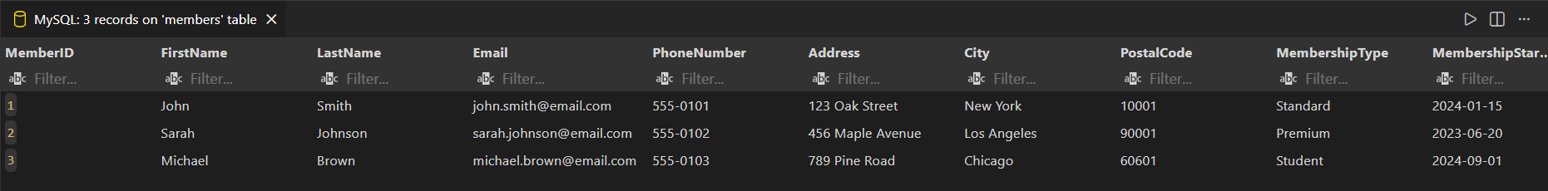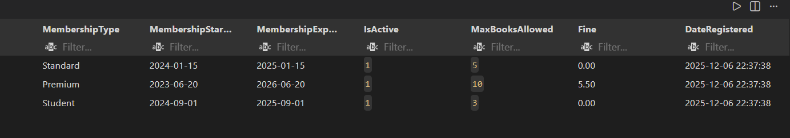

Task Description - 3 –Basic Queries
Task: Use AI to generate a query to list all books borrowed by a specific member

Code and Output:
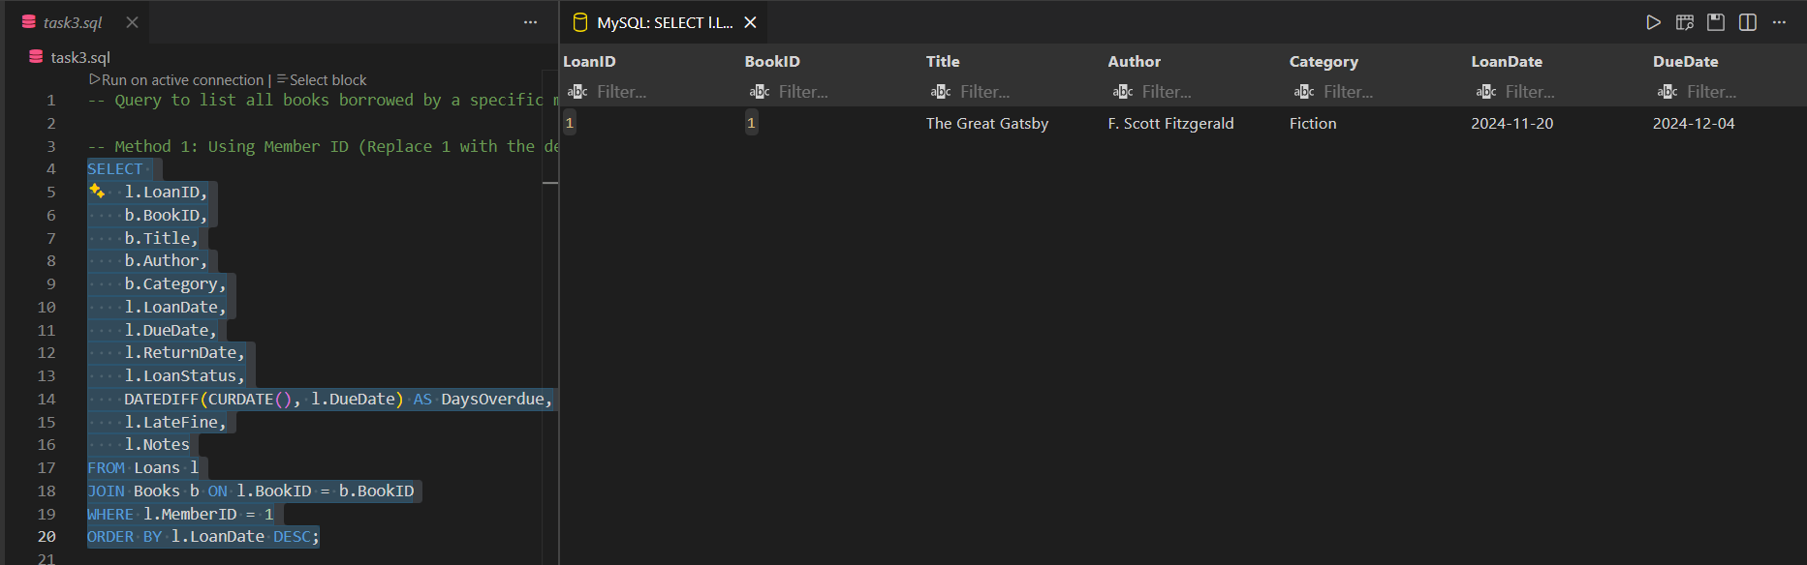
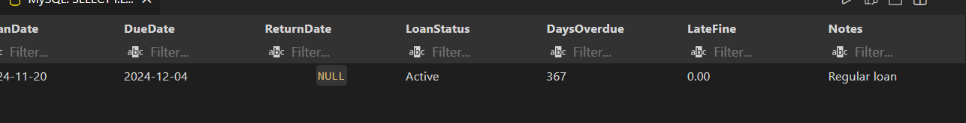

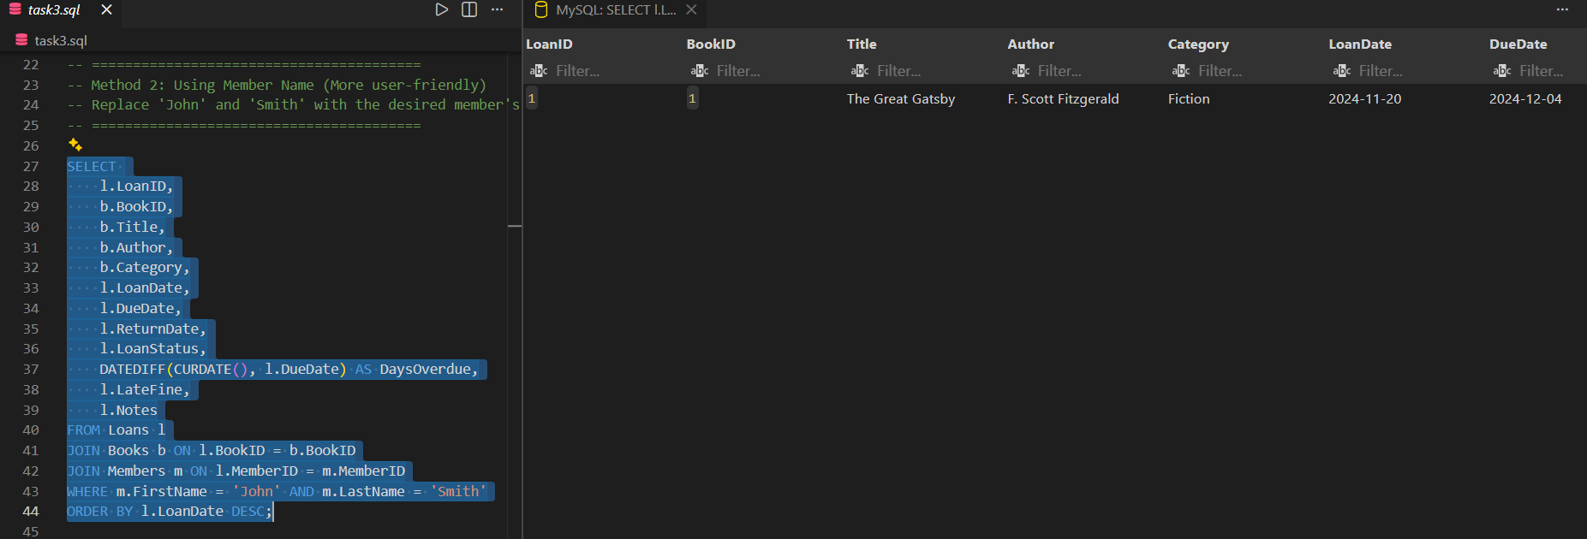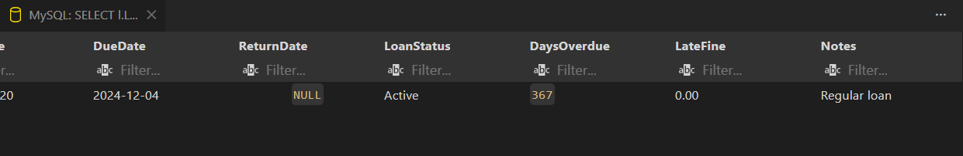

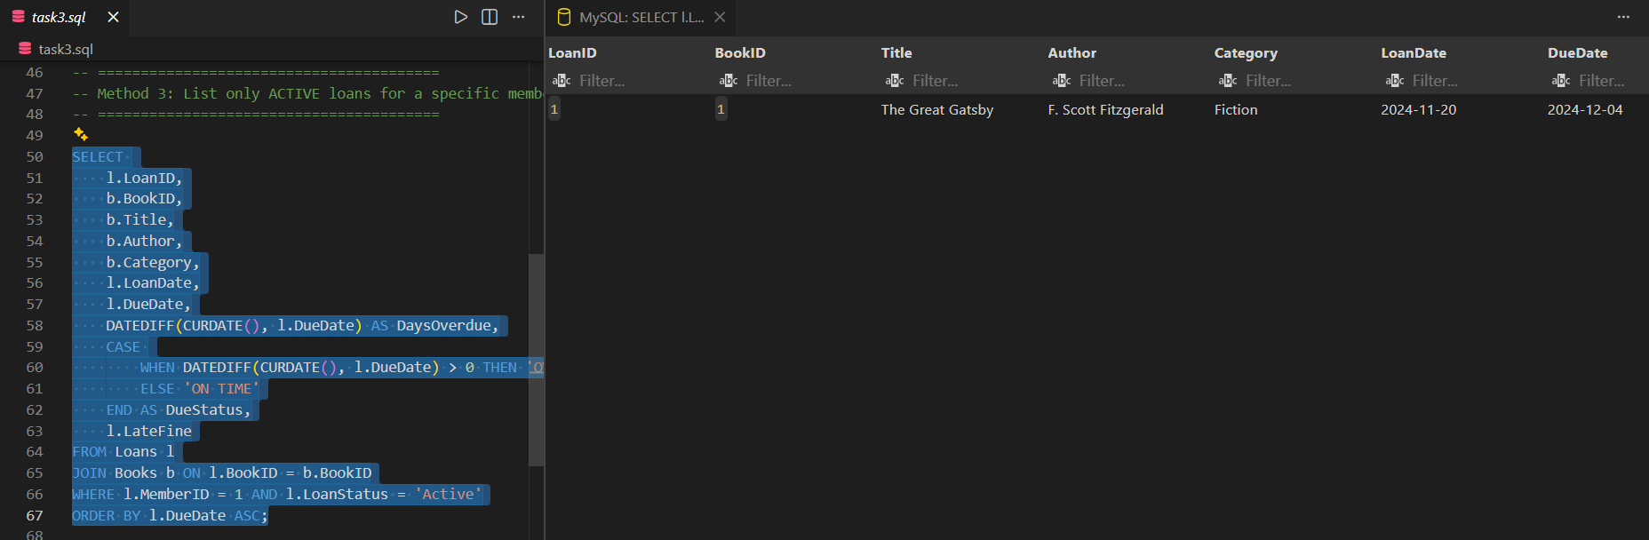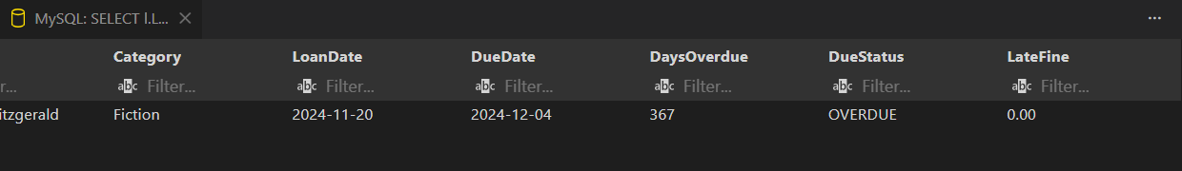

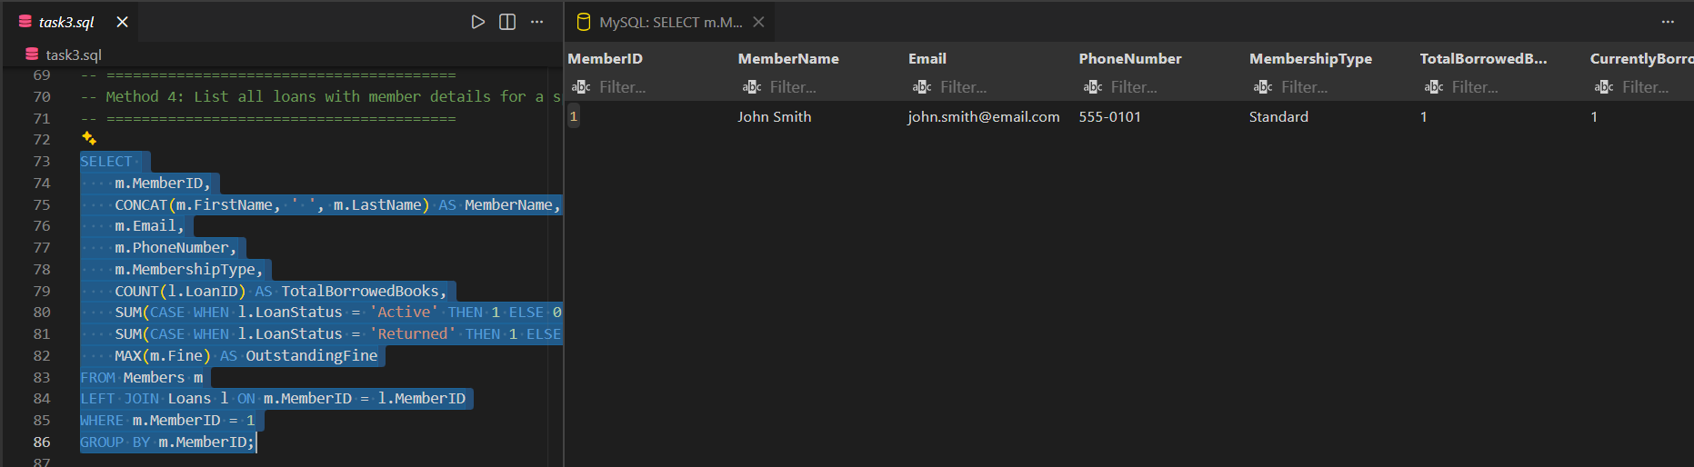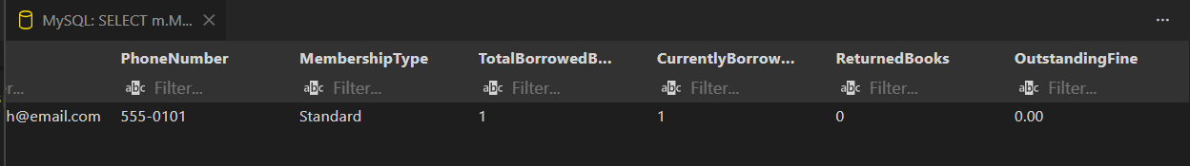

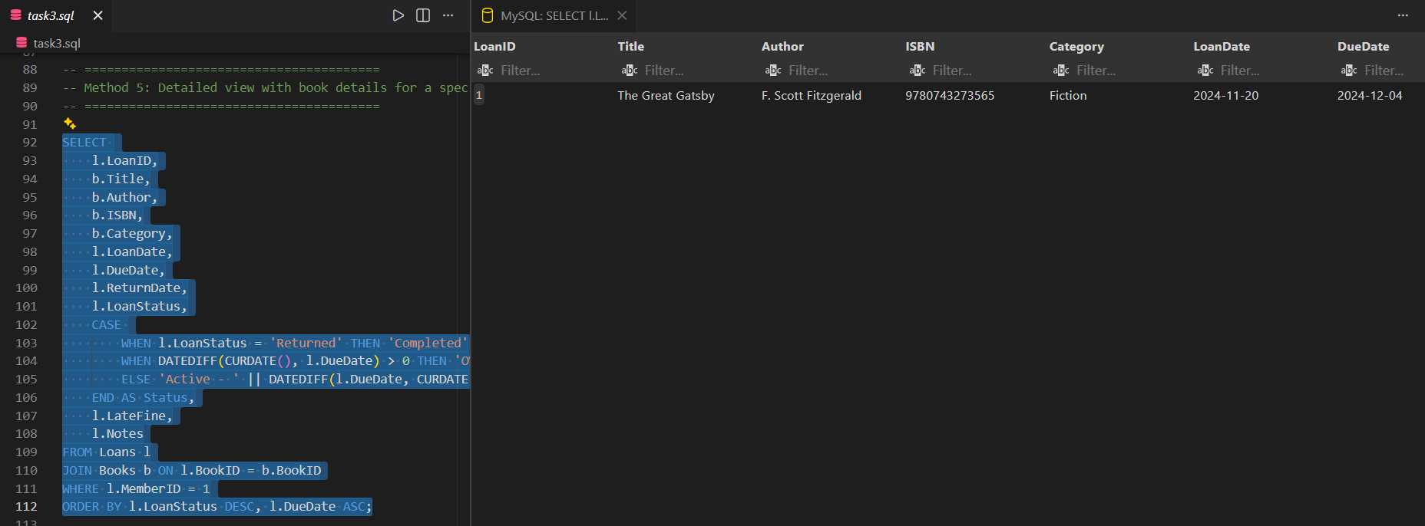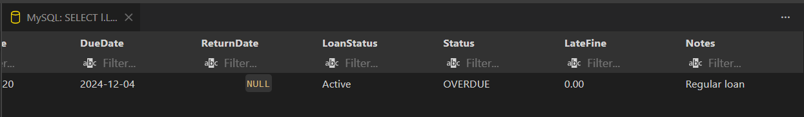
Task Description - 4 –Update and Delete Queries
Task: Generate queries with AI for:
- Updating a book’s availability to FALSE when borrowed.
- Deleting a member record safely.
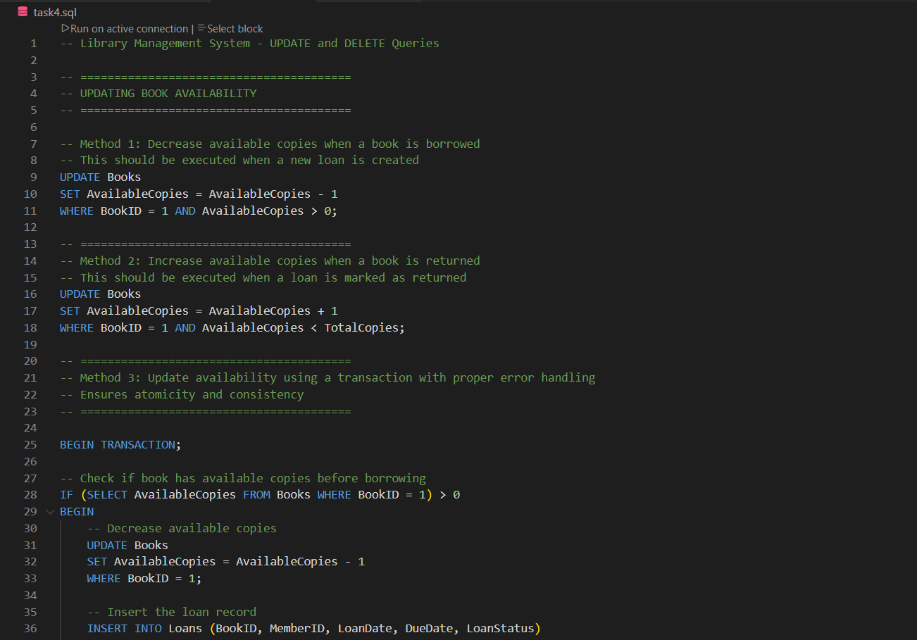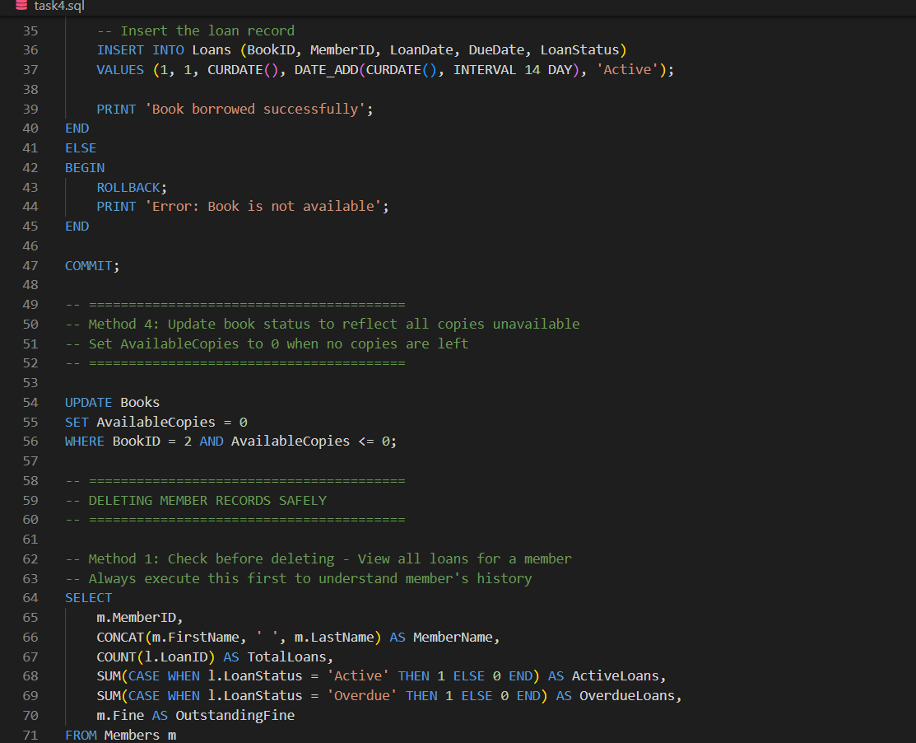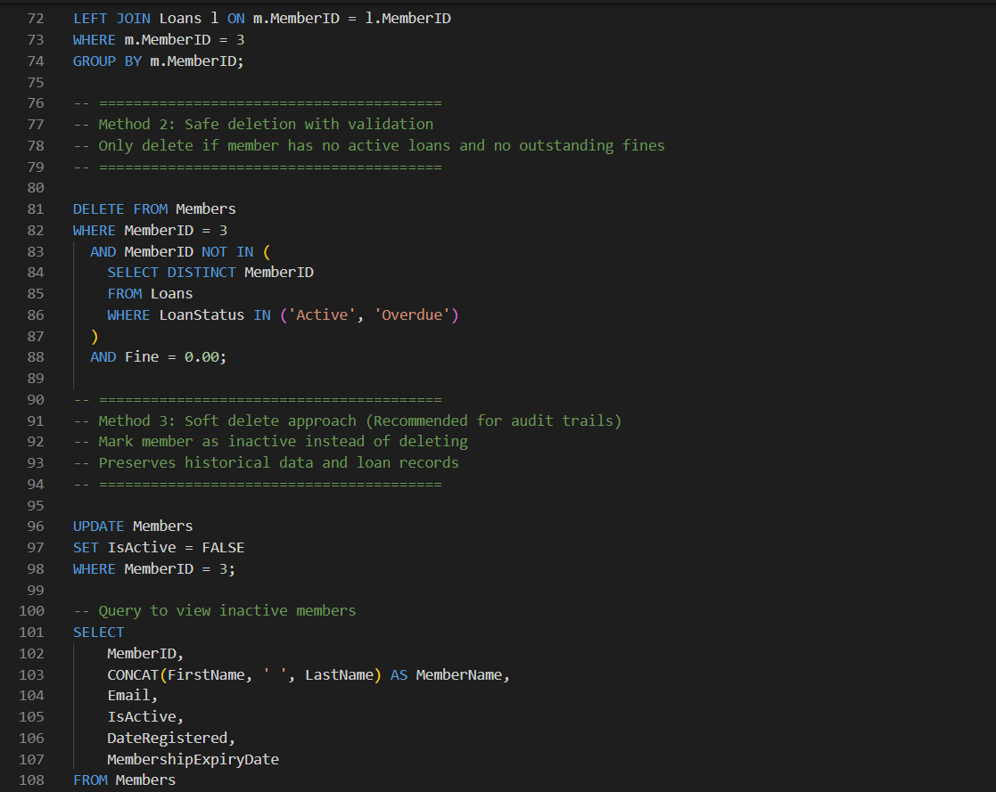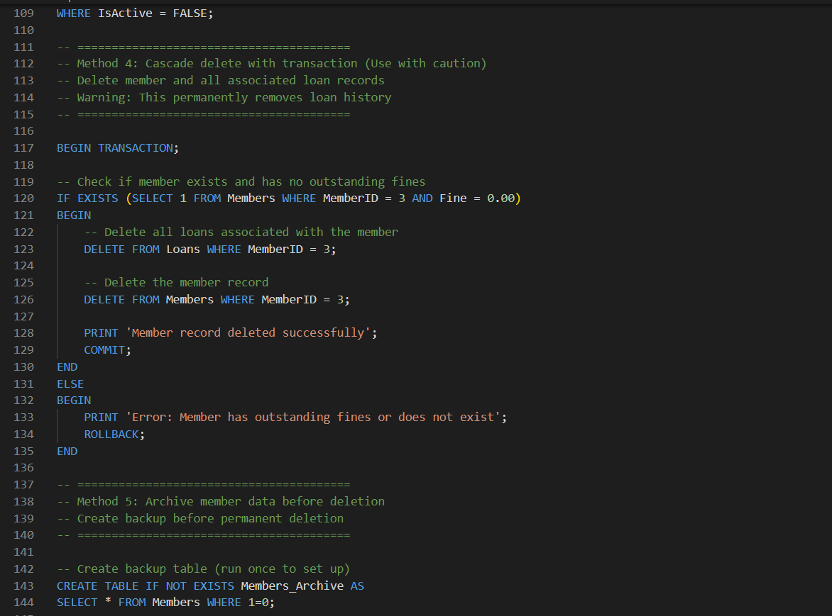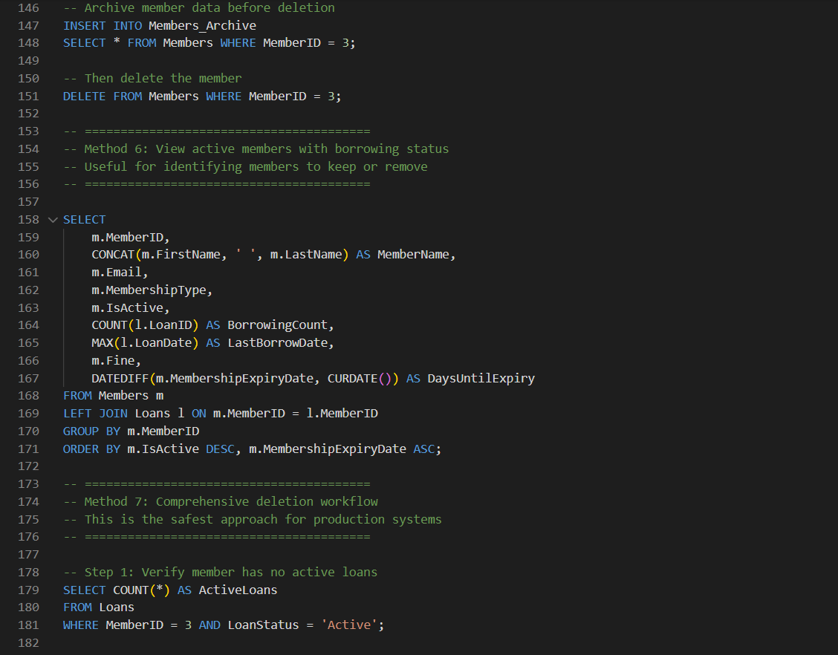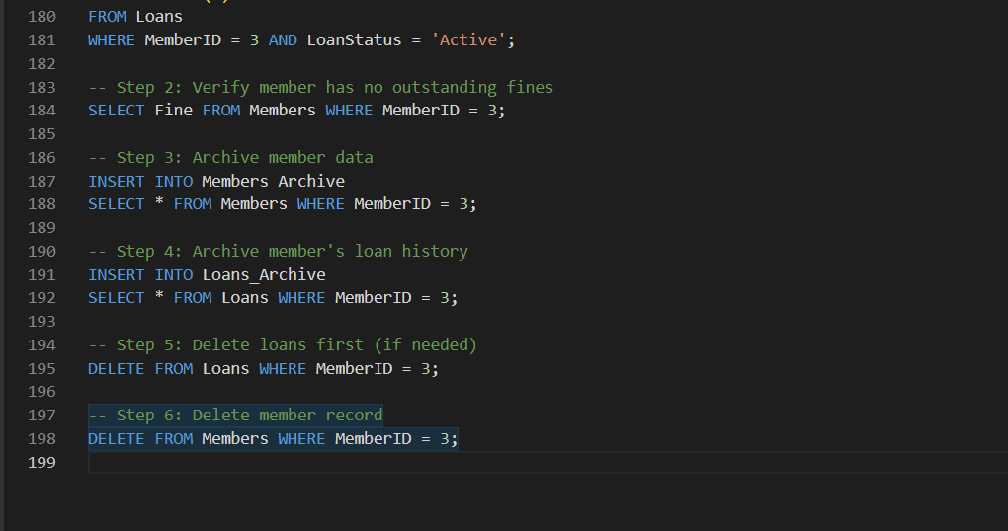

Output:
